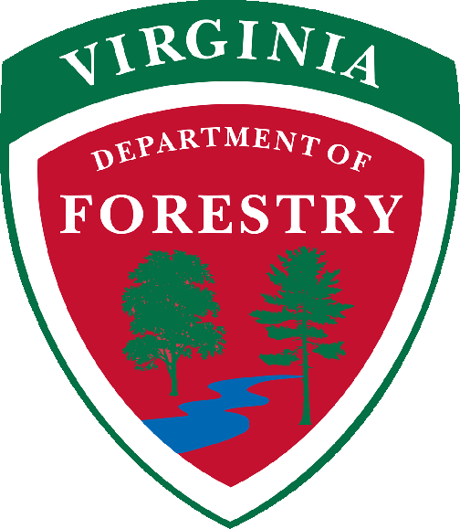
For Immediate Release Jan. 12, 2022
Contact: Cory Swift 434.365.8231

What to Know Before Burning Storm Debris

In the wake of recent storms that hit Virginia, officials with the Virginia Department of Forestry (VDOF) are encouraging people to practice safe burning if and when they began burning yard debris and blown down limbs and trees.
The VDOF regulates open burning and there are several rules, regulations, and tips that residents need to follow to stay safe, stay legal, and avoid undesirable impacts from smoke.
From February 15th through the end of April, it is illegal to burn BEFORE 4 p.m. if you’re within 300 feet of woods or dry grass leading to the woods. Visit https://dof.virginia.gov/wildland-prescribed-fire/ for complete regulations.
RESPONSIBLE BURNING:
- Start any burn as early as possible (after 4 p.m. during fire season), so the fire will have time to die down before evening sets in.
- Citizens also need to ensure that they follow any local burning ordinances that are in effect in their area.
- Have enough people on-site to keep the fire attended to and controlled at all times.
- Keep handy a water hose, shovel, or other means to put out the fire.
- Make sure the fire is completely out before leaving it. This means no smoke and no heat.
- Call 911 for help immediately if your fire escapes. Several minutes may pass before a fire department or the Forestry Department can arrive on the scene.
- Be aware that you might be held liable for the cost of suppression and damages to the property of others.
Burn piles should be:
- Located in an area that has been cleared down to bare soil.
- Less than 10 feet in diameter.
- At least 25 feet from any forested area (grasslands, brush or wildlands).
- At least 25 feet from your home or other combustible structure.
- At least 50 feet from any public roadway.
BURNING “DON’TS”:
- Don’t burn household garbage (including paper products), treated lumber, plastics, rubber materials, tires, pesticides, paint and aerosol containers. Burning these items is illegal.
- Don’t burn wet materials, as this creates excessive smoke.
- Don’t burn on windy days.
Don’t leave a fire unattended, even for a moment. Escaped debris fires can spread quickly.

-end-

The Virginia Department of Forestry protects and develops healthy, sustainable forest
resources for Virginians. With nearly 16 million acres of forestland and more than
108,000 Virginians employed in forestry, forest products and related industries, Virginia
forests provide an overall economic output of more than $21 billion annually.

Headquartered in Charlottesville, the Agency has forestry staff members assigned to
every county to provide citizen service and public safety protection across the
Commonwealth, which it’s been doing now for more than 100 years. VDOF is an equal
opportunity provider.

